Data



Mathematical Operations

|  |  |
| --- | --- |
| **AVERAGE AGE** | 21.6 |
| **Sum** | 213 |
| **MAX** | 22 |
| **MIN** | 20 |

Chart

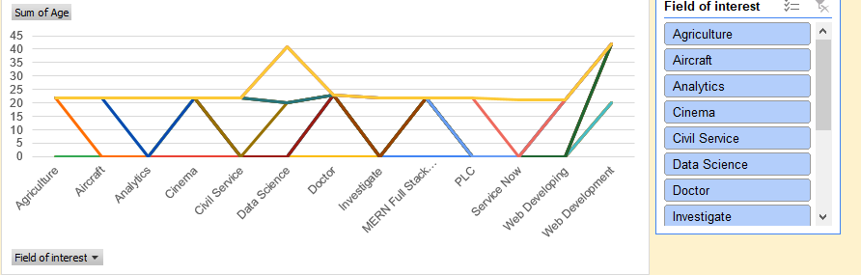

Dashboard

